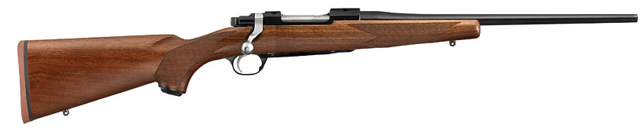  Rugar HawkEye predator rifle  with top of the line Leupold scope  Gun Raffle  For the  Annual Crab Feed  Hosted by:  The Battle Mountain Chamber of Commerce  GUN DESRIPTION: Caliber: 308 Barrel Length: 16.50” Trigger Features: Smooth, crisp Performance Cold Hammer-forged barrel with ultra-precise rifling that provides exceptional accuracy, longevity and easy cleaning *American Walnut Hinged solid-steel floorplate for easy unloading without having to chamber each cartridge LEUPOLD SCOPE ¼ MOA Finger Click 3:1 zoom ratio Waterproof & Fog proof One-inch Maintube 6061-T6 Aircraft Quality Aluminum Twilight light management system Scratch Resistant lenses  Gun Provided By:  Blind Eye Gunworks  (Local Gun Supplier)  Gun will be on display January 1st  through February 1st at  720 Gold Creek,  Battle Mountain NV | February 2nd, 2019  8 P.M  ────  $20 a Ticket  ────  At The Chamber of Commerce  ────  Over a $1,500.00  Value  ────  Must have cleared Background Check  Available for $25 at Blind Eye Gunworks  The Battle mountain chamber of commerce  625 South Broad Street  Battle Mountain, NV. 89820  775.635.8245  Battlemtncommerce@gmail.com  FACEBOOK:  Battle Mountain Chamber of Commerce

