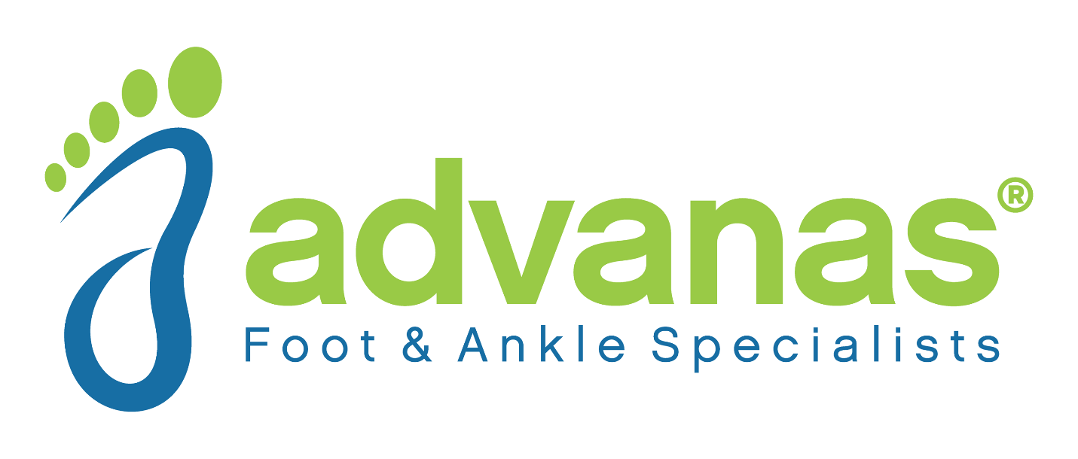

2019 Holiday Food Drive
Advanas Foot And Ankle Specialists is having a Holiday Food Drive and we need your help!
Stop in our Coldwater office Monday 9-7, Wednesday 9-1, or Thursdays 9-4
You can drop off non-perishable food items until December 3.

