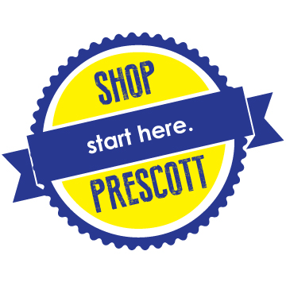Shop Prescott: Start Here Fact Sheet
Summary
The City of Prescott, the Prescott Chamber of Commerce and partnering organizations recognize the importance of supporting locally based brick and mortar businesses. Therefore we have launched Shop Prescott: Start Here, a campaign designed to educate the public about the importance of supporting local businesses every day. Shop Prescott: Start Here is launching in October, 2017, and will be ongoing. This is a Prescott-wide initiative that is supported by a number of organizations, and includes every business.
WHAT: Shop Prescott: Start Here is a campaign to education the public about the importance of supporting local brick and mortar businesses of all varieties.
WHY: Shop Prescott: Start Here was launched because local brick and mortar businesses have made a significant investment in our community, and are impacted by online businesses that extract money from the local economy and leave little behind. It’s time to stand up for them, and invite our residents and visitors to do the same.
WHEN: Shop Prescott : Start Here will launch in October, 2017. We are launching now in time for the holidays, but this will be a 24/7/365 campaign.
HOW: Shop Prescott: Start Here will educate the public in a variety of ways, including, but not limited to:
- Window displays in local businesses
- Signs and banners throughout Prescott.
- Press releases, media alerts and radio public service announcements.
- Website and social media activities.
- Speakers bureau going out to service clubs, schools, business organizations and meetings.
WHO AND WHERE: Shop Prescott: Start Here is a city-wide initiative. It is designed to include ALL brick and mortar businesses, from boutique stores, to restaurants, hotels, dealerships, educational institutions, and service businesses.
OTHER FACTS:
- There are over 10,000 businesses in Prescott that have made an investment in our community.
- Every dollar spent locally recirculates several times, it’s called the multiplier effect.
- Local businesses create local jobs, donate to local causes, and create tax revenue to support high quality public services and schools for Prescott.
- COMING SOON: ShopPrescott.net
For more information, Contact:
Prescott Chamber of Commerce 928-445-2000 OR City of Prescott Communications Office at 928-777-1362.

