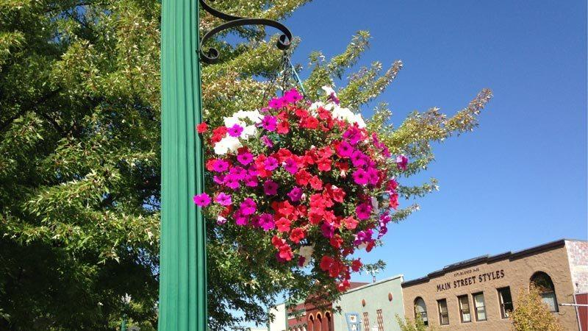
Do you enjoy the hanging flower baskets downtown each summer? The Quincy Chamber of Commerce would like to extend the flower baskets into East Quincy as well but this project takes time, effort and money…but first of all, it takes interest and cooperation! Please take a few minutes to tell us…if the flower baskets, brackets, soil and flowers were provided to your business, would you be able and willing to ensure that your basket is watered on a regular basis?

We have tested two flower baskets with self-watering reservoirs built in. The baskets are hanging at 1580 E. Main Street in front of Susan Scarlett’s office. The baskets were hung on August 19th. The first photo was taken the evening they were hung. The second photo was taken October 8th:

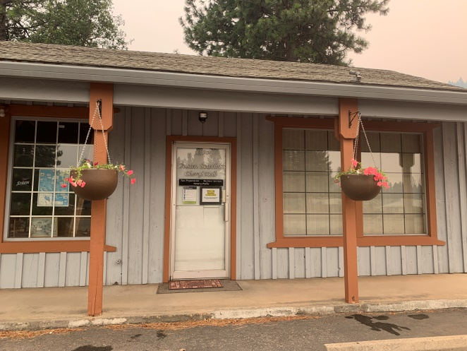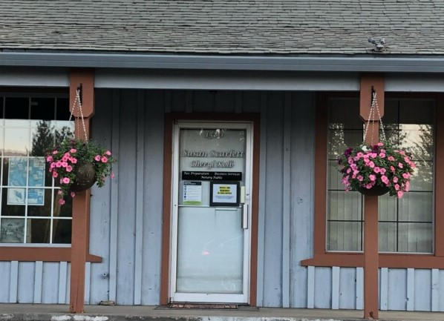

Again, these baskets have water reservoirs which reduce the frequency of watering. We have watered them once a week, and at one point we skipped a week to see how they would do (once a week is preferred). These baskets are not in direct sunlight, so businesses on the north side of Main Street or in full-sun locations will likely need to be watered at least twice a week.

Please take a few minutes to fill out the information below and return it to the Quincy Chamber of Commerce, PO Box 215, Quincy, CA 95971 before November 1, 2020. If you prefer you can email the form to us at info@quincychamber.com. This will help us determine whether this is a project worth pursuing for East Quincy.
----------------------------------------------------------------------------------------------------------------------------------------------------------------

- Yes, I would like to have basket(s) in front of my business. No, I do not want flower baskets.

Name of business: _____________________________________________________________________

Contact person: _______________________________________________________________________

Telephone or email: ____________________________________________________________________

Number of baskets you would like to have if possible: __________________

