**Who We Are:**

First Lutheran Church is an inter-generational congregation preaching God's word in the tradition of the Evangelical Lutheran Church in America.  We strive to strengthen everyone's belonging and involvement in the community of Christ, responsive to changing needs of families.  With Christ as our guide, we offer a stable, nurturing faith based environment to provide supportive ministry to all ages as a fulfillment of our baptismal promises.

**First Lutheran Church**  
920 East Third Street  
Cresco, Iowa 52136  
(563) 547-2092  
  
**Worship:**Sunday 9:00 a.m.  
**Fellowship:**Sunday 10:00 a.m.  
**Sunday School:** Sunday 10:00 a.m. (September-May)

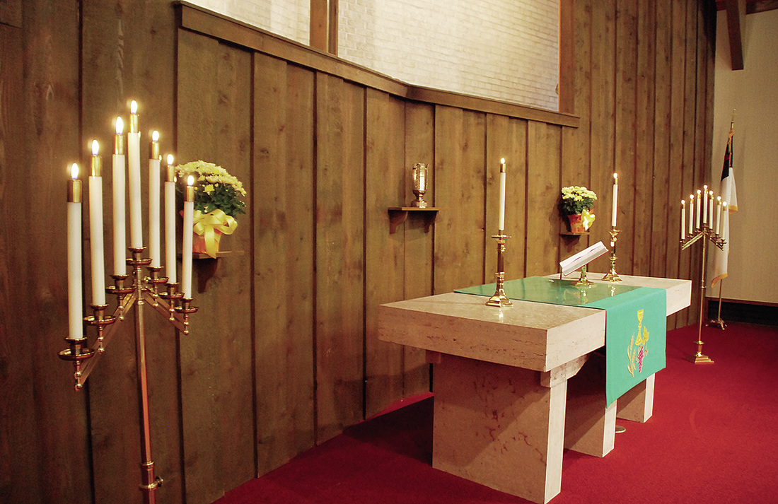

MAIL ADDRESS

flccresco@windstream.net

TELEPHONE NUMBER

(563) 547-2092

PHYSICAL ADDRESS

920 East Third Street  
Cresco, Iowa 52136

