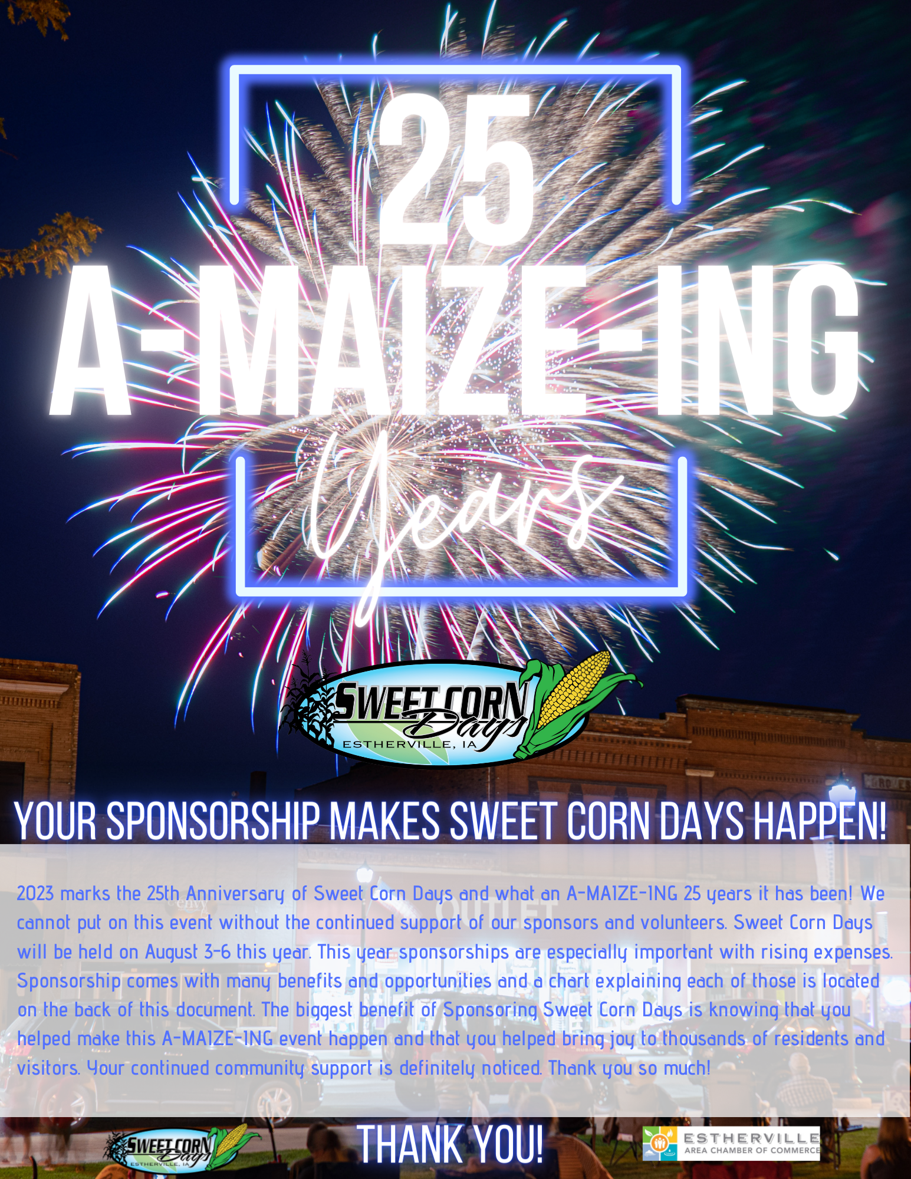

**kuoo’s 2022 $500 Tradeout gold sponsorship was greatly appreciated!**

**Kristen,**



**2023 Sponsorship Opportunities  
25 A-MAIZE-ING YEARS!**  
All sponsorships are greatly appreciated! Below is a chart explaining sponsorship opportunities at each level. Please mail form to 620 1st Avenue S or fax your form to 712 362 7742 and call the Chamber on 712 362 3541 with any questions.

|  |  |  |  |  |  |  |
| --- | --- | --- | --- | --- | --- | --- |
|  | Diamond Sponsor $2500+ | Titanium Sponsor  $1000 - $2499 | Platinum  Sponsor  $750-$999 | Gold Sponsor  $500 - $749 | Silver Sponsor  $300 - $499 | Bronze Sponsor  $100 - $299 |
| Major event (of your choice) sponsorship and recognition | X |  |  |  |  |  |
| Business Banner displayed on Mainstage (you must provide banner) | X | X |  |  |  |  |
| Business name on corn man displayed on Central Ave (Personalize Your own) | X | X | X |  |  |  |
| Business logo on the back of staff shirts | X | X | X |  |  |  |
| Business logo placed on event posters | X | X | X |  |  |  |
| Business Logo on schedules | X | X | X |  |  |  |
| Business Name on Schedules |  |  |  | X | X | X |
| Business Logo on website | X | X | X |  |  |  |
| Business Name listed on website |  |  |  | X | X | X |
| Tickets to the Street Dance | 8 | 6 | 4 | 2 |  |  |
| Recognition in a post event thank you advertisement | X | X | X | X | X | X |
| Preferred placement as a parade entry | X | X | X | X | X | X |

**Business Name to be used in print:___________________________________________  
Contact Name:________________________ Phone Number:_________________________________  
Sponsorship Amount Enclosed_________________ Please Bill Me______________  
I want to decorate my corn man** (Platinum Level +) **______ Yes ________ No Thank You**

**Thank you for your continued support of Estherville Sweet Corn Days!**Please return to the Chamber. For more information or for questions contact the Chamber.