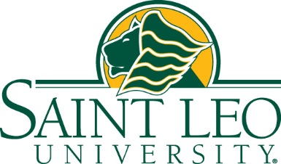

For immediate release: November 2, 2018
Saint Leo University-Lakeland to Hold ‘Virtual’ Info Sessions Nov. 8, Dec. 5
LAKELAND – Saint Leo University’s Lakeland Education Center will hold a series “virtual” information sessions in the coming weeks. The information sessions will take place at noon and at 6 p.m. on Thursday, November 8, and Wednesday, December 5.
Those interested in finding out more about Saint Leo, what degrees are offered, courses, and more are invited.
Beginning in the Spring 1 Semester, more than 50 undergraduate programs and a variety of graduate programs will be offered by Saint Leo University-Lakeland.
The Lakeland Education Center is at 315 Granada St., Lakeland, FL 33805. The center serves students in Lakeland, Winter Haven, Haines City, and other parts of Polk County as well as Plant City in Hillsborough County. Registration is underway for Spring 1 Semester, which begins Jan. 7, 2019. Spring 2 Semester begins March 4, 2019.
Prospective students and those interesting in more information can RSVP at lakeland@saintleo.edu call or (863) 337-4900.
About Saint Leo University
Saint Leo University (www.saintleo.edu) is a modern Catholic teaching university that is firmly grounded in the liberal arts tradition and the timeless Benedictine wisdom that seeks balanced growth of mind, body, and spirit. The Saint Leo University of today is a private, nonprofit institution that creates hospitable learning communities wherever students want to be or need to be, whether that is a campus classroom, a web-based environment, an employer’s worksite, a military base, or an office park. Saint Leo welcomes people of all faiths and of no religious affiliation, and encourages learners of all generations. The university is committed to providing educational opportunities to the nation’s armed forces, veterans, and their families. Saint Leo is regionally accredited to award degrees ranging from the associate to the doctorate, and the faculty and staff guide all students to develop their capacities for critical thinking, moral reflection, and lifelong learning and leadership.

The university remains the faithful steward of the beautiful lakeside University Campus in the Tampa Bay region of Florida, where its founding monks created the first Catholic college in the state in 1889. Serving more than 13,000 students, Saint Leo has expanded to downtown Tampa, to other sites in Florida and beyond, and maintains a physical presence in seven states. The university provides highly respected online learning programs to students nationally and internationally. More than 93,000 alumni reside in all 50 states, in Washington, DC, in three U.S. territories, and in 76 countries.

Media Contact: Mary McCoy, University Writer & Media Relations, mary.mccoy02@saintleo.edu, (352) 588-7118 or cell (813) 610-8416

