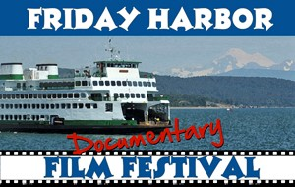
KEEP CALM AND FERRY ON!
PLAN AHEAD FOR YOUR TRIP
TO SAN JUAN ISLAND
The Washington State Ferry system will operate on an alternate schedule
Oct. 22 - Nov. 4. No reservations will be available during this time.
Check the schedule (CLICK HERE) and plan ahead!
Consider a stress free trip by parking your car and walking on the ferry at Anacortes. Hotels, film venues and town attractions are all within walking distance from the ferry landing. Public transportation and taxi options are also available from ferry landing and town of Friday Harbor.

THE FILM FESTIVAL
NEEDS VOLUNTEERS!
~EARN FILM TICKETS & SEE MOVIES WHILE ~VOLUNTEERING~
~THE FILM FESTIVAL HAPPENS BECAUSE YOU ~PARTICIPATE~
~STOP BY THE FHFF OFFICE - 10 FIRST ST., FRIDAY HARBOR~
~CALL US - 360-298-1939~
WEBSITE: www.fhff.org

