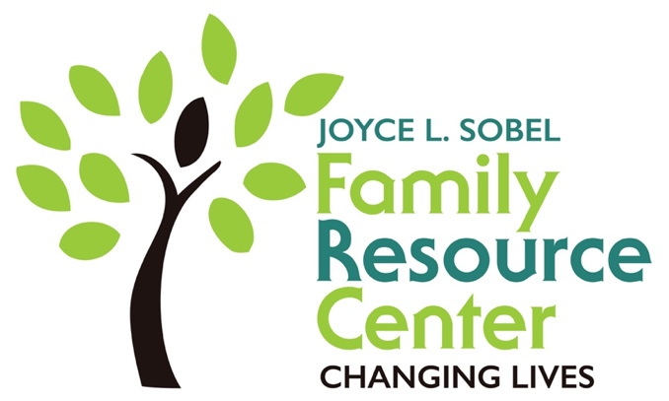

FOR IMMEDIATE RELEASE Contact: Jennifer Armstrong
Phone: 360-378-5246
sjifrc@gmail.com

HOLIDAY INSPIRATION

WHEN: Sunday, November 4
WHERE: Mullis Center
TIME: 2-4 pm
FREE

Join us for a Festival of Giving and Kindness

Celebrate others by: becoming a volunteer, sponsoring a family, mentoring a child, donating to our coat drive, making handmade gifts & cards, get a family photo

Celebrate yourself by: learning how to de-stress the holidays, practicing yoga, gaining health care access, enjoying healthy treats, simplifying the holidays, bidding on a beautiful quilt

See the Family Resource Center’s building expansion plans as we
RAISE THE ROOF!

KEEP THE HOLIDAYS MEANINGFUL BY PUTTING KINDNESS INTO ACTION

